American Presbyterians:
Origins and Distinctive Views
Community Presbyterian Church of Clarendon Hills
September 28, 2025

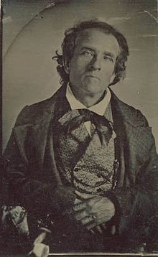 | 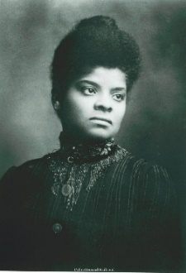 |  |  | 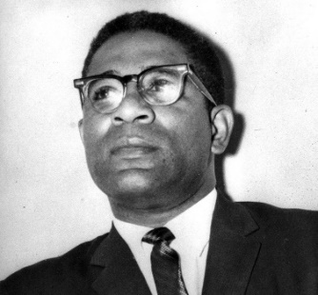
T.D. Weld (1803-1895) | Ida B. Wells (1862-1931) | Donald Trump (b.1946) | Fred Rogers (1928-2003) | Gayraud Wilmore (1921-2020)

Approaching a Diverse Tradition: Illustrations from literature

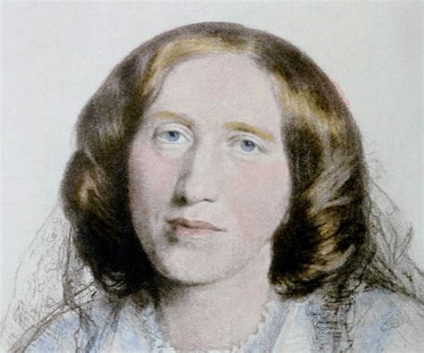  George Eliot (1819-1880) | 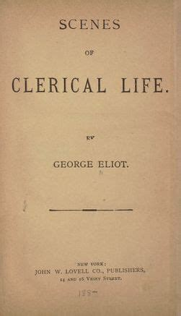

George Eliot. “Janet’s Repentance,” in Scenes of Clerical Life. London: Dent, 1910, first published Blackwood’s Magazine, 1857. | 'Pooh!' said Mr. Luke Byles, who piqued himself on his reading, and was in the habit of asking casual acquaintances if they knew anything of Hobbes; 'it is right enough that the lower orders should be instructed. But this sectarianism within the Church ought to be put down. In point of fact, these Evangelicals are not Churchmen at all; they're no better than Presbyterians.'  'Presbyterians? what are they?' inquired Mr. Tomlinson, who often said his father had given him 'no eddication, and he didn't care who knowed it; he could buy up most o' th' eddicated men he'd ever come across.'  'The Presbyterians,' said Mr. Dempster, in rather a louder tone than before, holding that every appeal for information must naturally be addressed to him, 'are a sect founded in the reign of Charles I., by a man named John Presbyter, who hatched all the brood of Dissenting vermin that crawl about in dirty alleys, and circumvent the lord of the manor in order to get a few yards of ground for their pigeon-house conventicles.'  'No, no, Dempster,' said Mr. Luke Byles, 'you're out there.  Presbyterianism is derived from the word presbyter, meaning an elder.'  'Don't contradict me, sir!' stormed Dempster. 'I say the word presbyterian is derived from John Presbyter, a miserable fanatic who wore a suit of leather, and went about from town to village, and from village to hamlet, inoculating the vulgar with the asinine virus of dissent.'  'Come, Byles, that seems a deal more likely,' said Mr. Tomlinson, in a conciliatory tone, apparently of opinion that history was a process of ingenious guessing.  'It's not a question of likelihood; it's a known fact. I could fetch you my Encyclopaedia, and show it you this moment.'

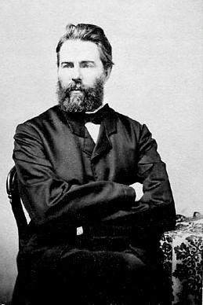  Herman Melville (1819-1891) | 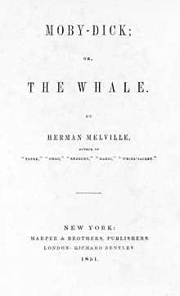

Herman Melville. Moby Dick or, The Whale. New York: Harpers, 1851. | I was a good Christian; born and bred in the bosom of the infallible Presbyterian Church. How then could I unite with this wild idolator in worshipping his piece of wood? But what is worship? thought I. Do you suppose now, Ishmael, that the magnanimous God of heaven and earth—pagans and all included—can possibly be jealous of an insignificant bit of black wood? Impossible! But what is worship?—to do the will of God—that is worship. And what is the will of God?—to do to my fellow man what I would have my fellow man to do to me—that is the will of God. Now, Queequeg is my fellow man. And what do I wish that this Queequeg would do to me? Why, unite with me in my particular Presbyterian form of worship. Consequently, I must then unite with him in his; ergo, I must turn idolator. So I kindled the shavings; helped prop up the innocent little idol; offered him burnt biscuit with Queequeg; salamed before him twice or thrice; kissed his nose; and that done, we undressed and went to bed, at peace with our own consciences and all the world. But we did not go to sleep without some little chat.

Smith, Amanda Berry. An Autobiography The Story of the Lord’s Dealings with Mrs. Amanda Smith, the Colored Evangelist : Containing an Account of Her Life Work of Faith, and Her Travels in America, England, Ireland, Scotland, India and Africa, As an Independent Missionary. Chicago: Meyer, 1893. |  | 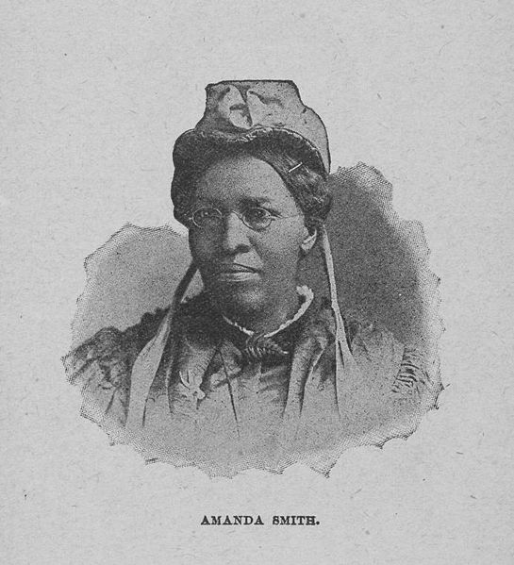
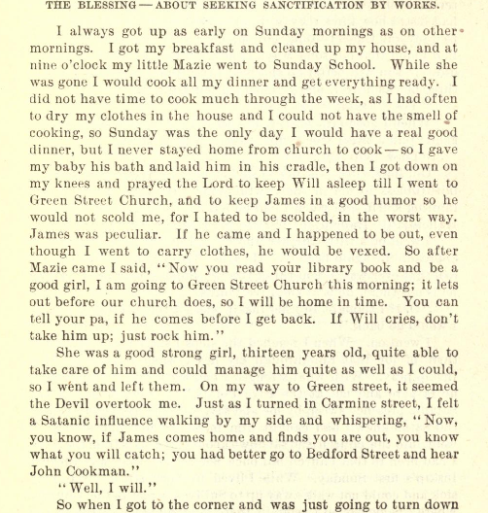
 | 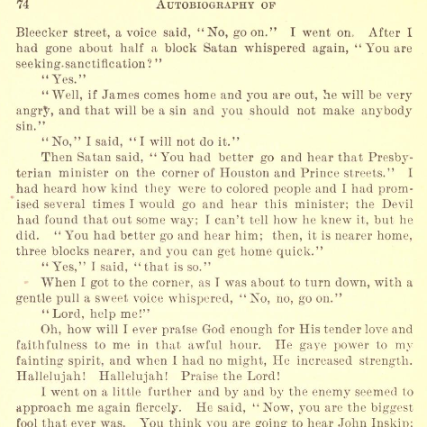
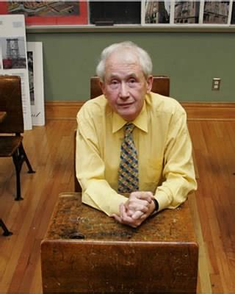  Fold3.comFrank McCourt (1930-2009) | 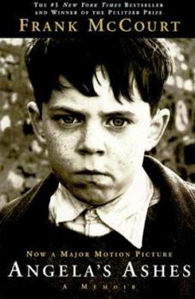

Frank McCourt. Angela’s Ashes: a Memoir. New York: Scribner, 1996. | The night before I was so excited I couldn’t sleep till dawn. I’d still be sleeping if my grandmother hadn’t come banging at the door.  Get up! Get up! Get that child outa the bed. Happiest day of his life an’ him snorin’ above in the bed.  I ran to the kitchen. Take off that shirt, she said. I took off the shirt and she pushed me into a tin tub of icy cold water. My mother scrubbed me, my grandmother scrubbed me. I was raw, I was red.  They dried me. They dressed me in my black velvet First Communion suit with the white frilly shirt, the short pants, the white stockings, the black patent leather shoes. Around my arm they tied a white satin bow and on my lapel they pinned the Sacred Heart of Jesus, a picture of the Sacred Heart, with blood dripping from it, flames erupting all around it and on top a nasty-looking crown of thorns.  Come here till I comb your hair, said Grandma. Look at that mop, it won’t lie down. You didn’t get that hair from my side of the family. That’s that North of Ireland hair you got from your father. That’s the kind of hair you see on Presbyterians. If your mother had married a proper decent Limerickman you wouldn’t have this standing up, North of Ireland, Presbyterian hair.  She spat twice on my head.  Grandma, will you please stop spitting on my head.  If you have anything to say, shut up. A little spit won’t kill you. Come on, we’ll be late for the Mass.
Andrew Stevenson. Chicago Preeminently a Presbyterian City.  Chicago: Winona Publishing Company, 1907. |  | 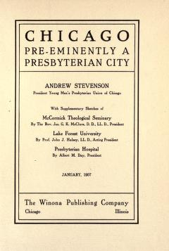
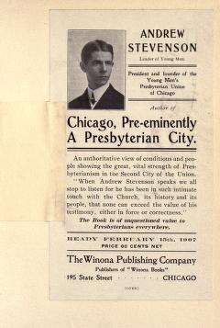 |  | 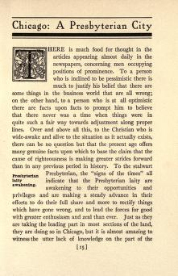

- Big Picture Origins and Divisions 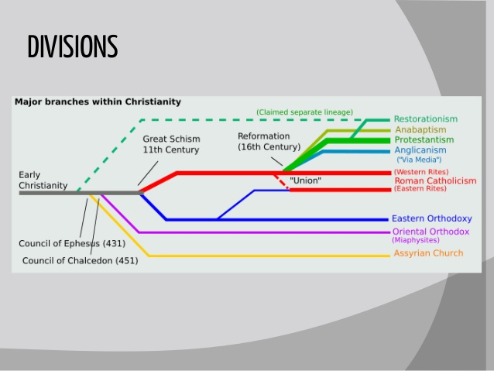slidesharecdn.com

- Beginnings in the Reformations of the sixteenth century
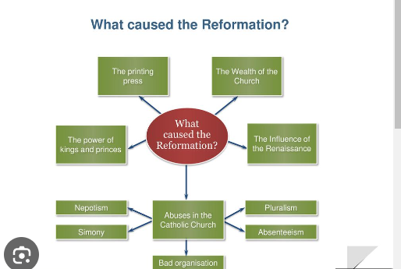slideplayer.com

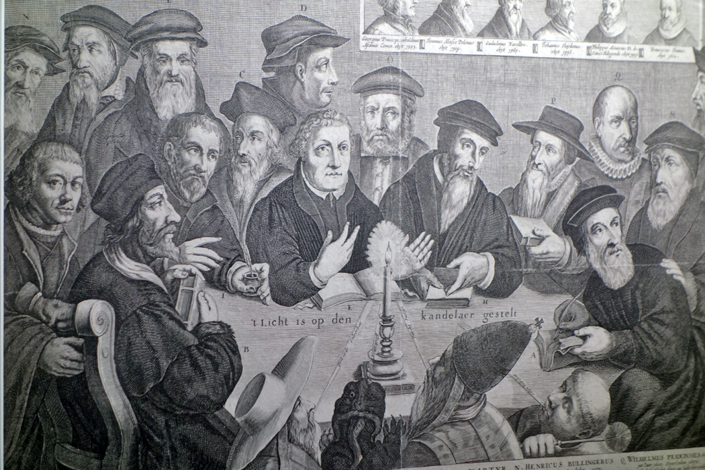
t Licht is op den Kandelaer gestalt (the candle is lit, we cannot blow it out!) [ca. 1650-1670]

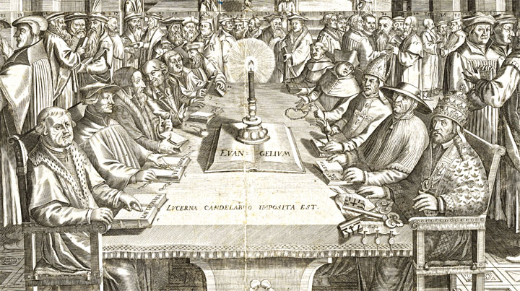
Johann Schwizer. Effigies Praecipuorum Illustrium atque Praestantium Aliquot Theologorum (1650)
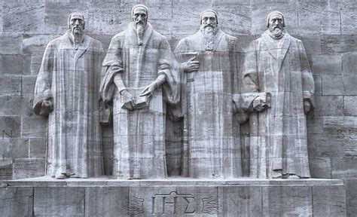

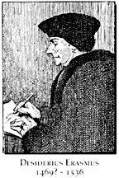 | 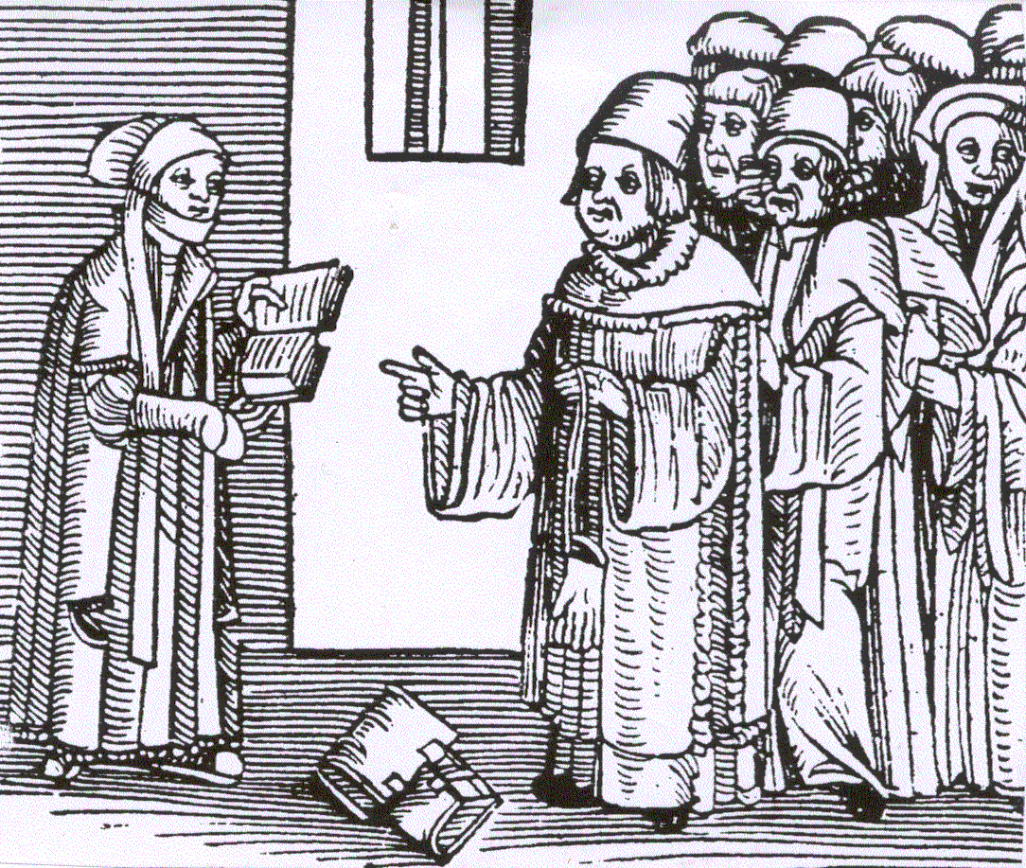  Argula von Grumbach 1492-1554? | 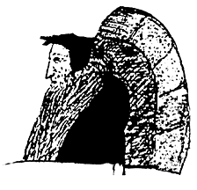  John Calvin 1509-1564
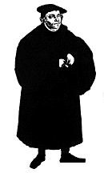Martin Luther 1483-1546 | 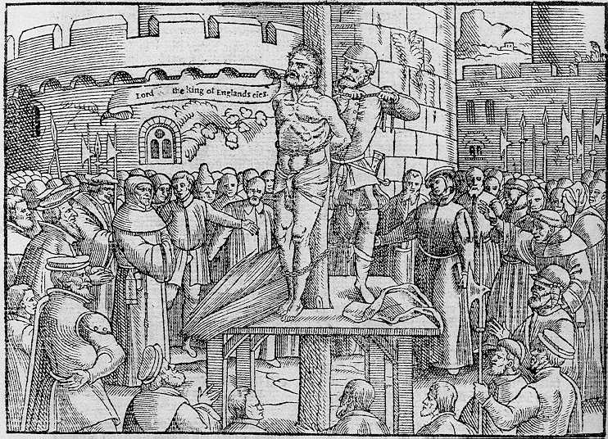  The execution of William Tyndale 1536 | 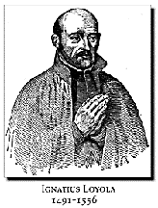

- Christian Humanism
- Luther and Lutheranism
- “Radical” reformers:
Anabaptists
anti-trinitarians
Spiritualists
revolutionaries
- Reformed folk: (Presbyterians fit here, but so do others.) Not a solo, but a chorus of witnesses
- Roman Catholic renewal and reform (the road to the Council of Trent)
- Anglican tradition: from the Church in England, to the Church of England

What are the agreements among the Reformers? Repudiation of Mass as sacrifice; revalution of vocation; repudiation of clerical celibacy; repudiation of mediated grace; elevation of preaching and of ordination; return to the sacraments; return of the sacraments to the people; Bible as norming norm; repudiation of Papal monarchy

What are some of the disagreements among the Reformers? The problem of idolatry, Sacraments, church/state ethics, Christology, pacifism, creeds and confessions, national or international

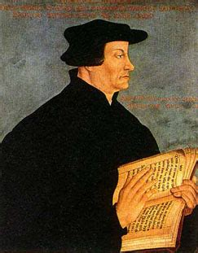Ulrich Zwingli  1484-1531 | 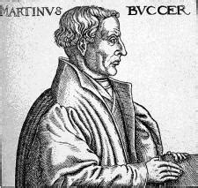Martin Bucer  1491-1551 | 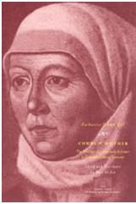  Katherine Zell  1497-1562 | John Calvin  1509-1564 |   John Knox  1513-72
A chorus of Reformed Protestants: an international movement

Distinctives and Characteristics of Reformed Christianity: a Reformation tradition, but with specific emphases:
- agreement with the methods of scholarship of the Christian Humanists

- Agreement with the central doctrinal reforms of Luther, but pressing a distinct reform on matters of tradition, worship, church/state, and regulation of reform

- The Bible experienced as a liberative word, and as an authorizing word. People are called to be scriptural people
- The problem of idolatry and the lure of “liberative iconoclasm”
- Law is a gracious gift of God, not a fearful threat. “Lord, I love thy law…”

- The world is the realm of God’s redemptive work. Faith calls people not to leave the world but to join in work of reforming of the self and service to community in all its forms

- Attention to power: asymmetries of power, concentrations of power, consequences of the absence of power, complacency in the exercise of power

- The Church is in the world, however uncomfortably and ambiguously. The Church is an institution, to be sure, but also a dynamic event in the world to seek to reflect God’s purposes/preferences and places

- Cultural questions will inevitably, eventually, imperfectly, be reflected in church culture – the doors of the Church are open to the issues of this culture, “for such a time as this”

- These times may require a statement, a confession, a declaration that is always:
Provisional
Partial
Professive

A Digression on forms of governance
- Episcopal
- Presbyterial
- Congregational

“The term ‘presbyterian’ arose in the 17th century among English-speaking Reformed Christians who sought to follow scripture in church government, providing for shared leadership between clergy and laity, and among local, regional, and national governing bodies.”
-James Moffatt

From Luther to Lutheranism, from Calvin to Calvinism, from the Old World to the New

  - Synod of Dort: a Reformed Council publishes a five point response to critics The “Five Points of Calvinism”
1643-1647 Westminster Assembly
The Westminster Confession
Examining Westminster documents
Responsive (reactive?)
Scholarly (scholastic)
Deductive (Decretal)

Prominence of Reformed voices in the American religious story
- An American invention: the denomination – voluntary --self-selecting/self-segregating
- Timelines and topics
- A Puritan past begets a pluralist present
- Polity expresses Reformed theological conviction among Presbyterians, Congregationalists, Anglicans, Baptists

Of “Congreterians” and “Presbygationists”!

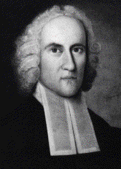 | 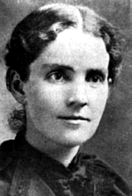 | 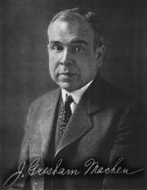 | 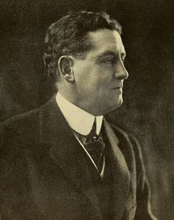
Edwards L. Woosley J. G. Machen J. T. Stone
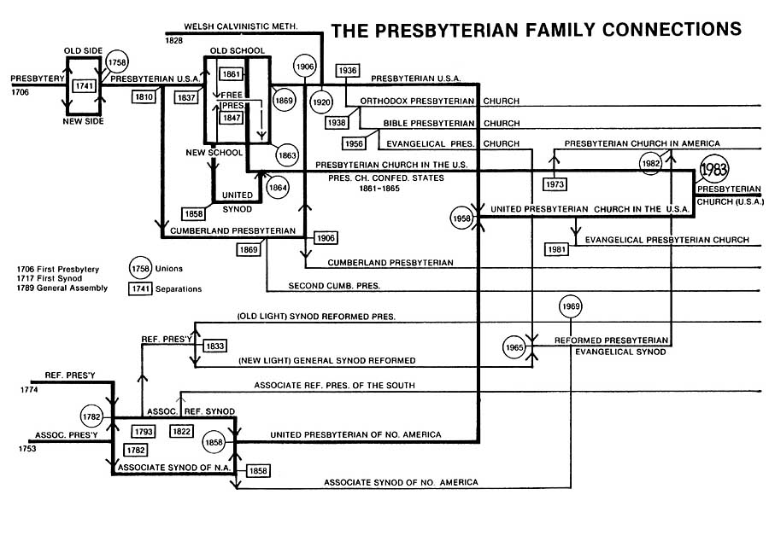

VII. Joining the Conversation: Sources
- Balmer, R., and J. Fitzmeier. The Presbyterians. Westport, CT: Praeger Publishers, 1994).
- Blight, David. Frederick Douglass, Prophet of Freedom. Simon & Schuster, 2018.
- Blumenthal, Sidney. The Political Life of Abraham Lincoln. 3 vols. Simon & Schuster, 2017-.
- Cashdollar, C. A Spiritual Home: Reformed Christianity in the Nineteenth Century. University Park: Pennsylvania State University Press, 2000.
- Coalter, Milton, John Mulder, and Louis Weeks, eds. The Re-Forming Tradition. Louisville: Westminster/John Knox Press, 1992.
- Loetscher, L. The Broadening Church. Philadelphia: University of Penn. Press, 1954 (reprinted 1964), now available through the Hathi Trust.
- Marsden, G. The Evangelical Mind and the New School Presbyterian Experience. New Haven: Yale University Press, 1970.
- Sawyer, K. “Colonial American Presbyterian History.” Encyclopedia of Religion in America, edited by Charles Lippy (CQ Press), 2009.
- Smylie, J. A Brief History of the Presbyterians. Louisville: Geneva Press, 1996.
- Trinterud, L. The Forming of an American Tradition. Philadelphia: Westminster Press, 1949. (reprinted 1970).
- Weston, W. Presbyterian Pluralism: Competition in a Protestant House. Knoxville: University of Tennessee Press, 1997.
- Wilmore, G. Black and Presbyterian: The Heritage and the Hope. Revised edition. Louisville: Witherspoon Press, 1998.
- Yoo, William. The Presbyterian Experience in the United States: A Sourcebook. WJKP, 2017.
- __________.Reckoning with History: Settler Colonialism, Slavery, and the Making of American Christianity. WJKP, 2025.
- __________.What Kind of Christianity: A History of Slavery and Anti-Black Racism in the Presbyterian Church. WJKP, 2022.

Some Online Pan-Presbyterian Resources:
- Presbyterian Church(USA) (at www.pcusa.org )(many links, many texts)
- Presbyterian Historical Society exhibits and publications at: https://pcusa.org/historical-society/history-online/exhibits
- United Church of Christ at: www.ucc.org
- Presbyterian Church in America at www.pcanet.org
- Evangelical Presbyterian Church at www.epc.org
- Orthodox Presbyterian Church at www.opc.org
- Cumberland Presbyterian Church at www.cumberland.org
- Associate Reformed Pres. Churches at www.arpsynod.org
- World Communion of Reformed Churches at: https://wcrc.edu

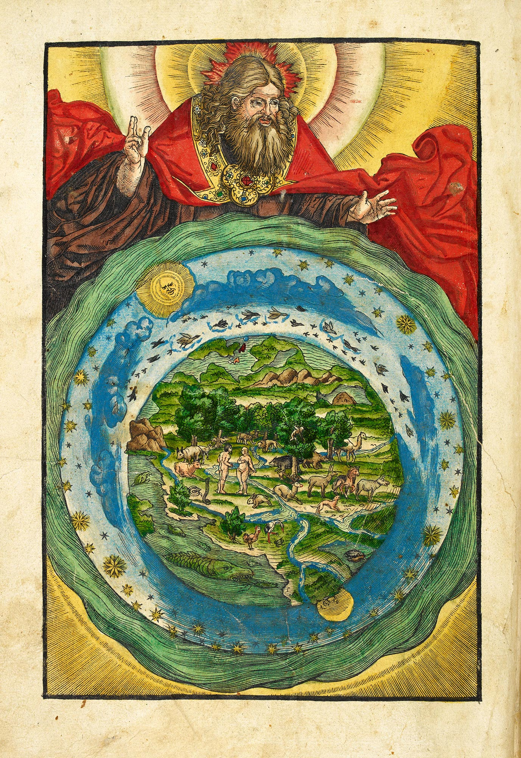
Luther Bible 1534

